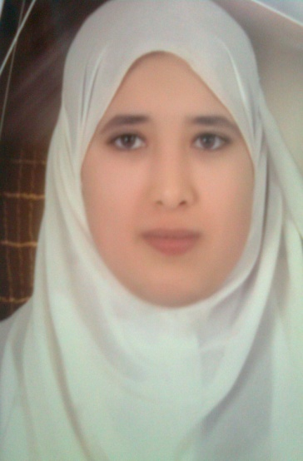**Sara Hamdy Ahmad**

**Objective**

**To enhance my experience and increase my opportunities to achieve a good position and a good work reputation in the firm or the project I work in.**

**Personal Data**

**Date of Birth : 6/6/1994**

**Address : 6 Saad Zaghloul St. Assiut, Egypt**

**Mobil : 01025340608**

**Home : +2350827**

**E-Mail :00sarahamdy@gmail.com**

**Qualification - B.S, of science, Chemistry and Microbiology Department,**

**Faculty of Science, Assiut University.**

**(General Grade: B- with GPA 2.75 in July 2016).**

**-Diploma Biochemistry in Faculty of Science, Assiut University.**

**(General Grade: B+ with GPA 3.47 in Sep 2022).**

**Other Qualifications &Training Courses**

**-August 2024,** Introduction to python**.**

**- February 2024**, Fundamentals of TinyML on edx.

- **December 2023**, Artifical Integlance (Ai) on Udacity

**- April 2022,** Search Engine Optimization (SEO) on Edraak

- **Sep 2021,** Digital Marketing Professional Track in The Egyptian Ministry of Communications grant in digital transformation on Udacity. .

**- July 2021,** Digital Marketing Challenger Track in The Egyptian Ministry of Communications grant in digital transformation on Udacity.

**- July 2021,** Data Analysis Challenger Track in The Egyptian Ministry of Communications grant in digital transformation on Udacity.

**- August 2016,** Food Microbiology Training in Animal Health Research Institute Assiut Lab.

**- September 2015**, Diagnosis and Medical Analysis in CDAR Lab.

**- November 2013,** Medical Representative Basic Diploma in Target Training Services &Pharma Egypt Pharmaceuticals.

**Experience**

**- Med. rep. in Rovamed pharma company (May2023_ until)**

**- Junior Med. Rep. in Health Well Egypt Company (Dec 2016_Aug 2021)**

**- Training on medical analysis in El-Mabara hospital - assiut**

**Languages Arabic** Mother Tongue

**English** good

**Deutsch good**

**Professional Strengths**

Hard worker and appreciate teamwork spirit. -  
 Ability to work under pressure.-

- Self-education ability.

**Computer skills**

-fast writing on computer with english

- Digital marketing

Photoshop -

**Hobbies & Activities**

Reading and Drawing. –

**It really gives me the pleasure to be a member of your great staff cadres team.**

**S. Hamdy**